The Current Statement of a VR Construction Design APP (II)
(DECO7230)

Basic detail

Full Name: Jiepeng Huang
Student Number: 47352580
Practical Session: 04
Demonstrator Name: Ben Ross

Statement of Originality

I certify that the following used in the current prototype with different origins:

All assets or models used in the current version of the application are made by me, except the house model, VR camera and VR hands.

The scripts and shaders are rewritten by me from the Meta or Unity packages template, which will be referenced in this delivery.

The media for recording the process: photos and videos are made by me.

References for all external resources can be found on page 13 of this document.

The concept

Introduction (recap and evaluation)

As I mentioned last time, my concept would be a 3D construction design software in a VR version. It allows the user to design and interact with the building in an immersive way to better simulate the realization of the building.

Before starting the investigation in prototype 1, I had decided to explore the following three key tasks/interactions:
- The adjustment of the angle of daylight exposure:
Users can use grab interaction to change the light angle through an interactable object, which allows them to simulate different shadow situations.
- The adjustment of the scale zooms:
Users can use a designed gesture to change the scale of a virtual reality world with buildings.
- the movement of the designer:
Users’ location will be changed by the movement of users in the real world.
Through the test using prototype 1 [6], I have received many valuable opinions from users and tutors, which helped me have a specific direction for the implementation of prototype 2.

In prototype 2, users will be allowed to interact with the application in a VR environment. The following tasks demonstrate achieved interactions in the current version:
- The adjustment of the angle of daylight exposure:
Users can grab an interactable sun model and move its location in a solid line range. So the angle of light for the entire VR environment will be the angle of the sun model hitting the terrain.
- The adjustment of the scale zooms:
Users can use a designed gesture (fig. 3) to change the scale of a virtual reality world with buildings. There will be a text asset showing the current scale.

The Form of the Prototype 2

Overview

Prototype 2 is the most recent presentation of the overall design so far, and we can start by briefly checking how it compares to the previous original design and Prototype 1.

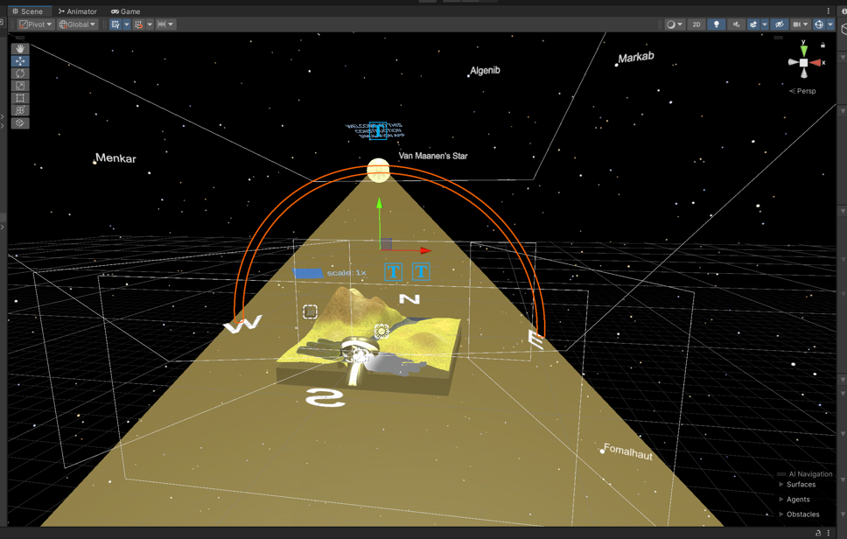
Fig 1: The overview of Prototype 2
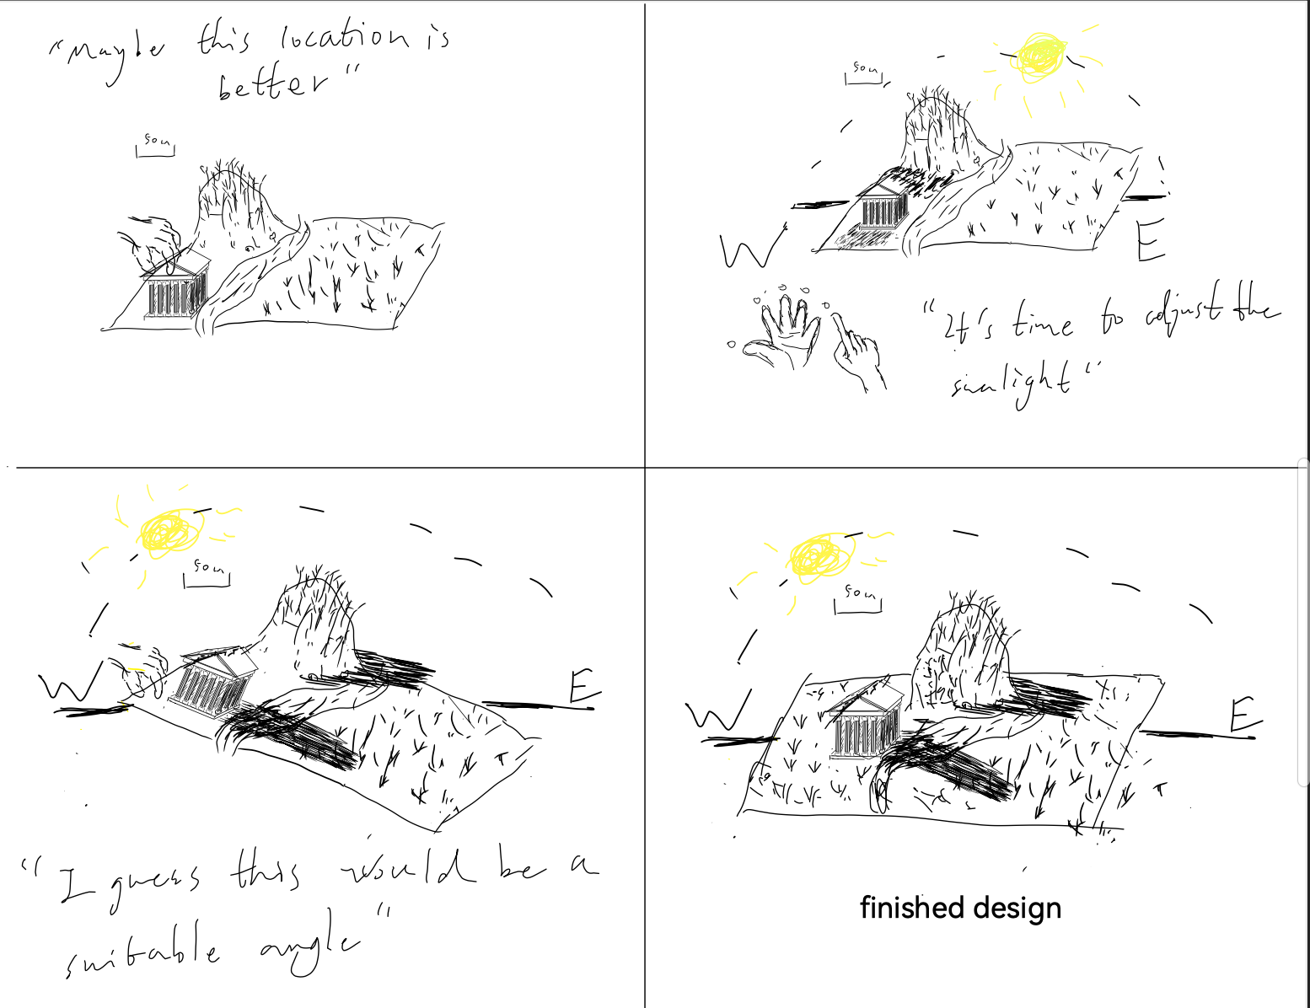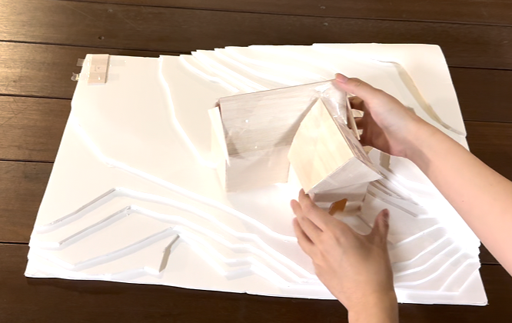
Fig 2: The overview of original storyboard(left) and Prototype 1(right)

As we can see, they have a similar structure and continued design concepts. Prototype 2 is also made up of several separate systems or components, which I have divided into the following sections:

- The player with the camera, which is based on the Meta template asset. [1]
- The ground system, which is an interactable terrain. [3][5]
- The sunlight system includes a sun model and indicators.
- The zooming feature system includes sensors and indicators.
- An interactable house model. [2]

Obviously, all but the first are implementations of the original design, with the fourth being the main focus of this test. This is in line with the planning of future work in the previous report. Due to word limitations, other system descriptions will be attached to the appendix (page 10).

The zooming feature system (The main topic)

The system is implemented mainly through gesture recognition and camera zoom, which are based on meta script templates. After setting up a specific gesture, the application recognizes when the user is posing that gesture and changes the camera scale accordingly. The gesture is set up as a two-handed gesture so that the application can judge the scale achieved by the distance between the user's hands. As a result, when the user pulls their hands apart, the objects in front of them will appear to be zoomed in. Also, they will be zoomed out when their hands are closer together.
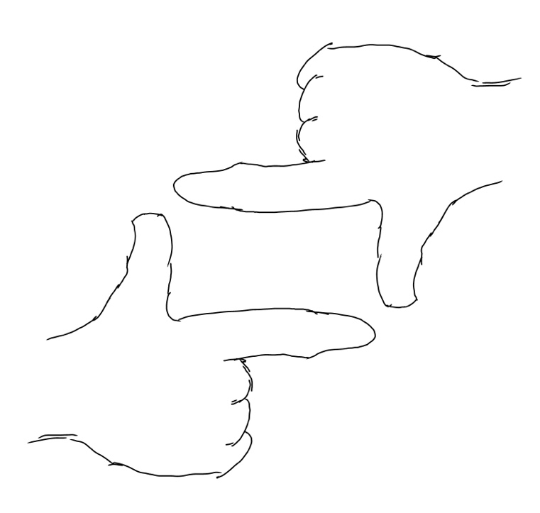
Fig 3: The gesture for recognition in the zooming system, which was drawn by me.

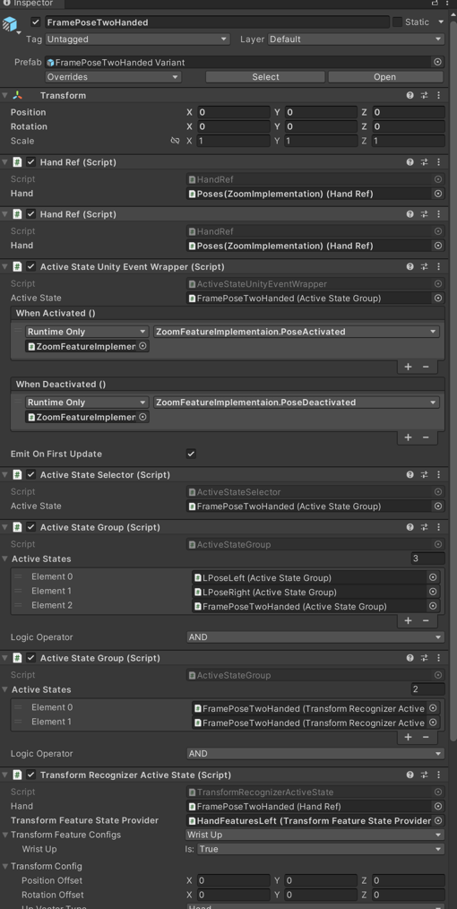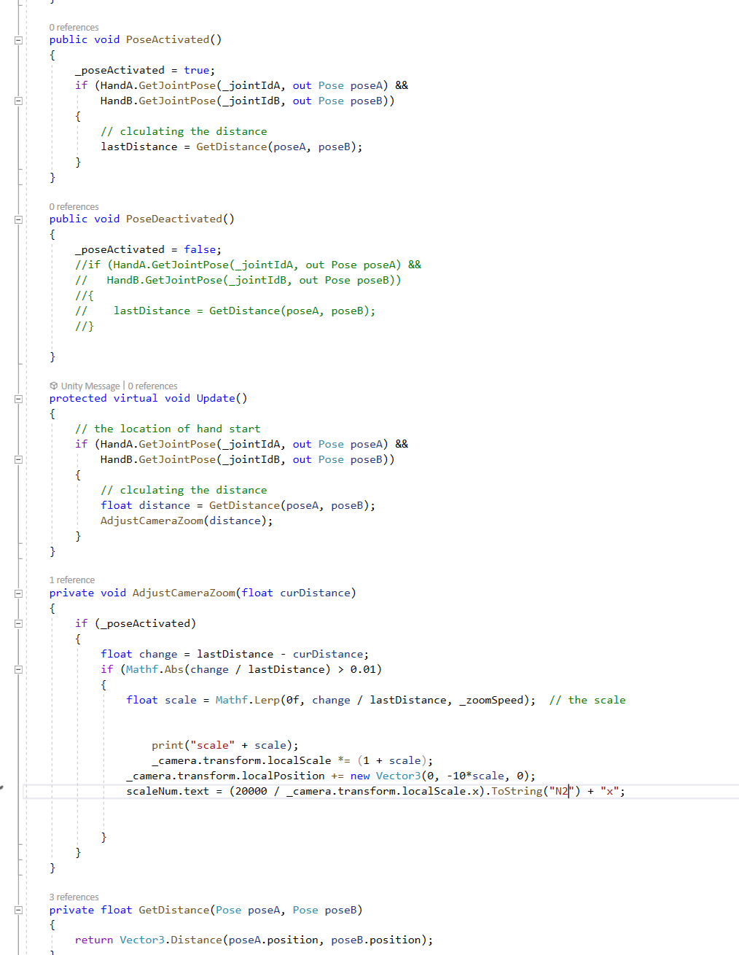
Fig 4: Some parts of the implementation of the zooming system

At the same time, I've also set up corresponding instructions for users to learn the gestures used for interaction and to show changes in scale.

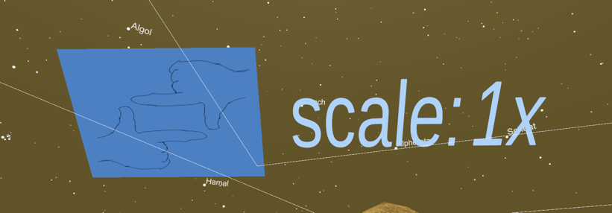
Fig 5: The indicators for the zooming system

The Purpose of this testing round

In this round of testing, I was more about extending the design concepts from Prototype 1 and making improvements based on the results of the first round of testing. This is because in the first round of reports I have got the validity of the current design direction (a building simulation application). Therefore, I could focus on converting prototype 1 to the Unity version.

In the future work part of the previous report, I've decided that the focus of this round of testing would be on the implementation of zoom-in/zoom-out interactions, which means the ability for the user to zoom in and out of the entire VR world with a specific gesture. So, the main parts I need to implement are the gesture recognition function, the zoom-in/zoom-out function, and the world being zoomed out/zoomed in. These ended up being the zooming function system I mentioned earlier.

This ultimately allowed me to gather users' feelings and opinions on the interaction feature in this round of testing. I will use this test to determine if this is a suitable and effective implementation of the interaction and get directions for improvement.

The other functional systems are more of a faithful representation of Prototype 1 and a complement to the application integrity and interaction integrity. But I'll be gathering some feedback on this as well.

Testing Agenda/Protocol

Evaluation Method

In the prototype 2 test, the primary goal of this study is to explore the user experience and potential improvements for a specific interaction in a high-fidelity VR construction simulation environment. The task I am focusing on is:
- Scaling the VR Environment with Gestures (The main topic): Participants will use predefined hand gestures to zoom in or out, allowing them to adjust the size of the entire VR environment.
The implementation of the completed design in Prototype 1 also be an additional part of the current prototype so that the feedback from users will be simultaneously collected from the following tasks:
- Sunlight Adjustment: Participants will use an interactable sphere object to change the daylight angle in a VR environment, which allows them to simulate different kinds of daytime in the application.
- House Placement: Users would be asked to pick up the house model and place it wherever they think it fits best. Hence, they will have the freedom to move the house around the terrain, considering factors like lighting, terrain shape, and overall spatial preference.
This experiment mainly uses think-aloud and interviews to collect data, while three simple quantitative questions are also designed to be used for analysis in the interviews. Participants will be asked to give feedback on each task using these same three questions. [6]

Here are the questions:
- Do you think this interaction is intuitive for future users? (1-5)
- Do you think this interaction is easy to learn for future users? (1-5)
- Do you think this interaction is useful for future users? (1-5)

Participants

Students from UQ

Experiment Process

Users will go straight into the app to explore, and the experimenter will keep encouraging them to express their ideas and make sure they try out all the interactions. At the end, there will be a short interview with quantitative questions to collect feedback.

Evaluation Outcomes & Reflection

During the studio class in week 8, I collected feedback from three volunteers in total. After that, I added a volunteer for enough information gathering. I have graphically presented the results of the three quantitative questions through the code.

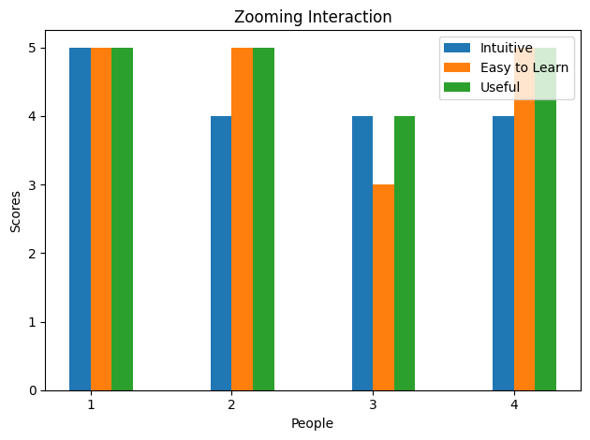
Fig 6: The feedback about the feeling of the zooming interaction

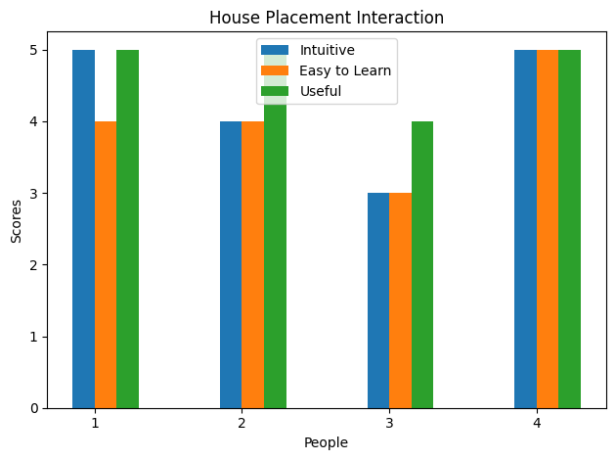
Fig 7: The feedback about the feeling of the house placement interaction

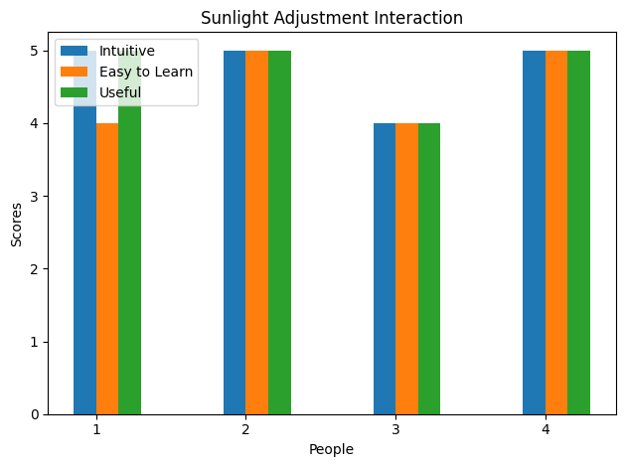
Fig 8: The feedback about the feeling of the sunlight adjustment interaction

quantitative analysis

Feedback from the data suggests that the current version of the Unity application implementation is very effective, and users are generally satisfied with the current implementation. The only thing that needs to be pointed out is that they don't find it very easy to learn the interactions for placing the houses. This may be due to the fact that the house model only has a very small domain to interact with when the world is at a smaller scale, and there is no guidance for learning this interaction within the application.

However, for the subject of this test, the scaling interaction, users were quite happy with the current experience. While users mostly did not rate the intuitive nature of the interaction out of ten, this could be due to the fact that this interaction requires the use of a specific gesture, which is somewhat limiting to the user.

Also, in the realization of the test results from the prototype 1 light adjustment interaction, the results are positive.

qualitative analysis

think-aloud

In the records obtained through think-aloud, all volunteers expressed basic satisfaction with the experience in the application. But it's pretty obvious that users need guidance to experience all the interactions. In addition to this, some users were confused about the goal of the application, so it is necessary to enhance the guidance of the interactions.

Interview

In the interviews, volunteers expressed very important suggestions for the next design direction. They generally agreed that player movement is not a necessary interaction in the current application, so I think this may not be an important next direction for implementation. In addition to this, one volunteer pointed out that while VR interactions have their place in need of redesign, it is also important to retain a design language that is consistent with other domains.

Volunteers also offered more suggestions for current interaction systems. These suggestions can be broadly summarized as follows:
1. Having alternative forms for one interaction, including the zooming interaction.
2. Having more precise recognition of interactions.
3. Having more introduction or guidance for interactions.
4. The Direction Indicators should not rotate with the terrain.

Conclusion

This test explored feedback on the implementation of Prototype 1 and experience with the zooming interaction. Volunteers were generally satisfied with the current implementation but also suggested many areas for improvement, such as learning guides for the interaction and errors in the implementation. Importantly, the move to allow the user to realise the player's position through gesture interaction was generally seen as unnecessary. Therefore, this will be excluded from future plans and changes will be made accordingly.

Reflection

As I participated in other people's testing, I felt the importance of guidance. Although the test is about the interaction function itself, almost all interactions require experimenter guidance for learning. Therefore, I will try to enhance the guiding information of the interaction. In addition, simple interactions can sometimes work well, but unintuitive interactions can be more frustrating. For example, I was a little confused when trying to interact with someone else's app and found that the actual interactable area didn't match the shape of the object.

Testing Plan (Future Work)
The best part of this implementation is undoubtedly the zoom interaction system, which is the most fully implemented in the current version. The current version will be further refined in Prototype 3, but will not implement the player movement interaction planned in the previous report.

The plans for the prototype 3 are as follows:
- Modify errors on the current implementation.
- Add more guidance on the current interaction.
- Implementation of gesture interaction for selection of different buildings.

Electronic Journal Link

https://drive.google.com/drive/folders/1IjcwneCCmutk6pHCLKQItPgfVzD8lyb6?usp=drive_link

Video Link to The Prototype

https://youtu.be/mSP4Lys0c1E

Appendix

The player with the camera

This system mainly applies the VR camera asset provided by Meta, while adding components that allow hand interaction. It is worth noting that the proper position and size were set to ensure that the user could load the correct view.

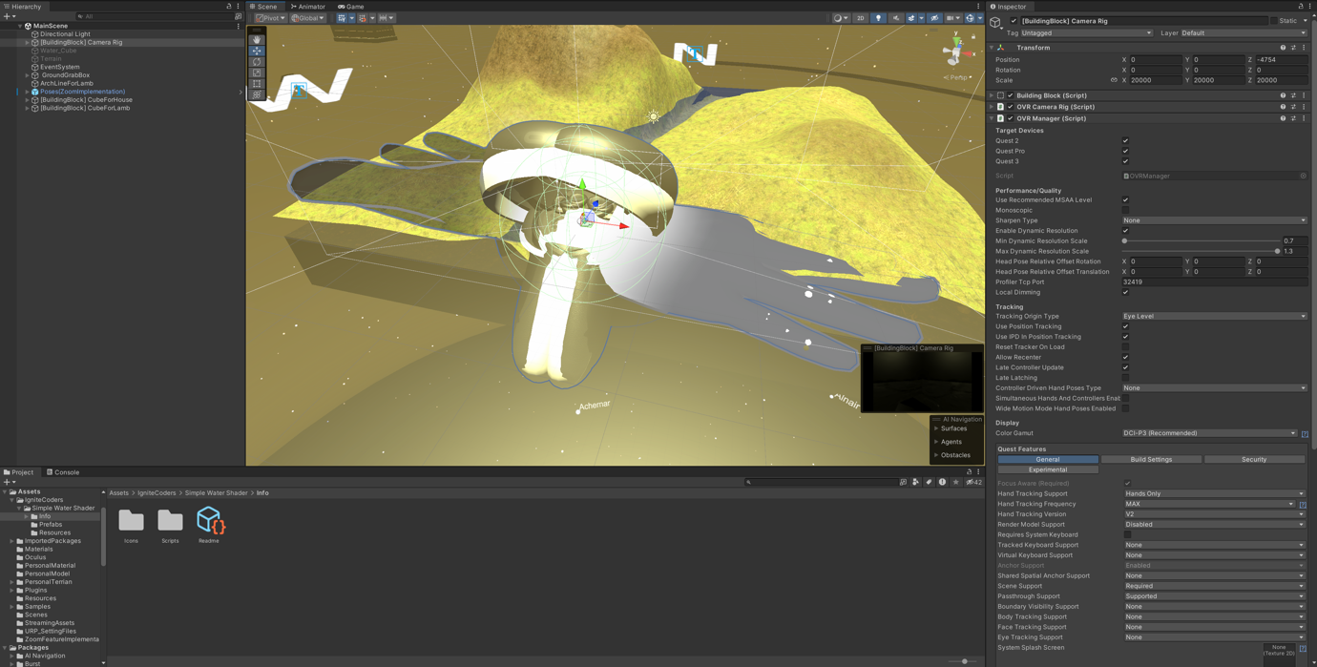
Fig 9: The camera system (Camera Rig asset) with settings in the Unity project, which people can see the hand model and controller model.
The ground system

I made the current terrain using Unity's own terrain tool and the free terrain transformer tool plugin, which allows the users to rotate it in the horizontal plane using grab interaction. I disabled rotation in the vertical plane and arbitrary positional movement because they do not fit the simulation of what is possible in the real world. In short, this basically fulfils the plan of the original design.

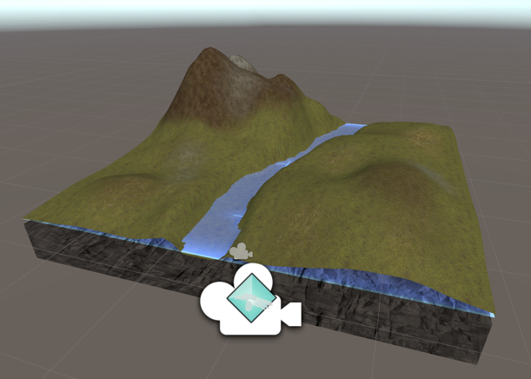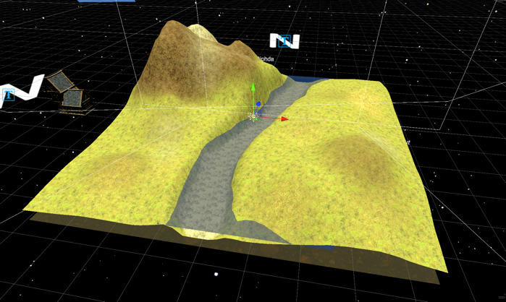
Fig 10: The ground system, with an early version (left) and the final version in the whole project (right).


Fig 11: The original concept of the ground system in the previous storyboard.

In addition, the river part was created as a separate plane component and used an external free water material. The interaction part, which can be grabbed by the user, is an invisible box that contains all the structures. The user can actually interact with some space above the ground, which enables easier interaction.

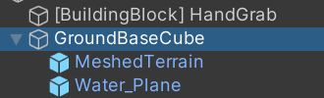
Fig x: The component structure of the ground system.

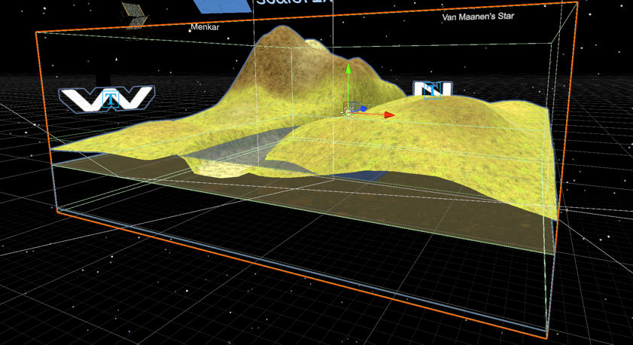
Fig 12: The interactable domain of the ground system (The orange/red line box).

The sunlight system

After getting the results gathered through prototype 1, I finally decided on the current version of the light system. It consists mainly of a ball component that can be grabbed and interacted with and a semicircle that indicates the range of movement of the ball. The user can grab this glowing ball and move it to any position on the line, thus adjusting the angle of the light. This system works in conjunction with the rotation of the terrain system to simulate real-world light conditions at various times and locations.

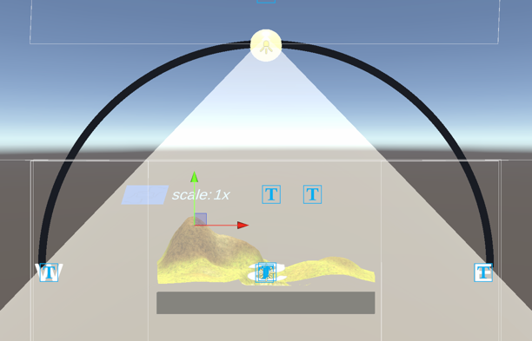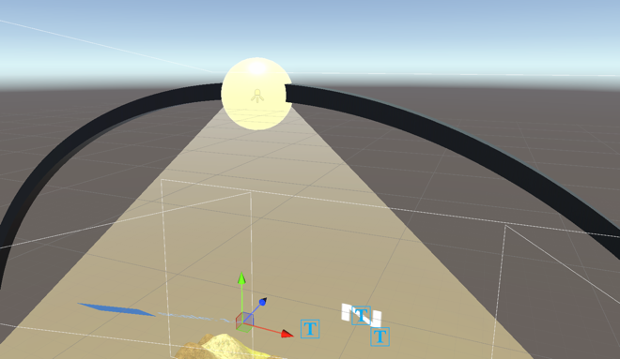
Fig 13: The structure of the sunlight system includes a sun model (the yellow sphere) and its range (the dark line).

The interactable house

As a building simulation app, buildings are indispensable. I ended up importing a simple model of a house and binding a Meta grabable component to it. In the end, the user will be able to change his position through the grabbing interaction.

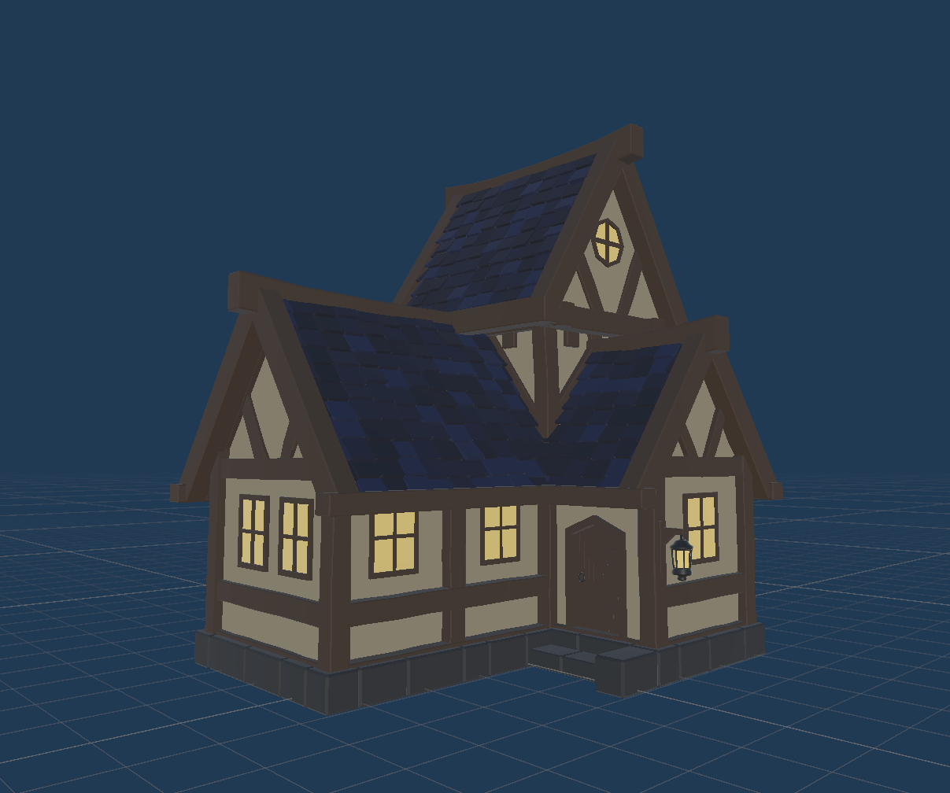
Fig 14: The house model

This actually fulfils the original design idea of changing the position of the house by grabbing.

Reference

[1] The Meta all-in-one package source:
https://assetstore.unity.com/packages/tools/integration/meta-xr-all-in-one-sdk-269657

[2] The house model asset source:
https://assetstore.unity.com/packages/3d/environments/fantasy/fantasy-house-bundle-257964

[3] The water material asset source:
https://assetstore.unity.com/packages/3d/environments/waterworks-simple-water-ocean-river-system-for-urp-reflection-re-206909

[4] The skybox asset source:
https://assetstore.unity.com/packages/3d/environments/sci-fi/real-stars-skybox-lite-116333

[5] The terrain editor plugin source:
https://assetstore.unity.com/packages/tools/terrain/mesh-terrain-editor-free-67758

[6] My prototype 1 source:
https://drive.google.com/drive/folders/1dBvjtcIOuqX4Q7XEFmfbn2m3r2t8CHVt?usp=drive_link

